**PRACTICAL-5**

**AIM**

Configure a windows FTP server for user-based access. Capture packets while you connect to FTP server and Login. Find the packet that shows username and password. Capture packets and observe the results.

**THEORY**

**FTP**

* FTP (File Transfer Protocol) is a network protocol for transmitting files between computers over Transmission Control Protocol/Internet Protocol connections. Within the TCP/IP suite, FTP is considered an application layer protocol.
* In an FTP transaction, the end user's computer is typically called the local host. The second computer involved in FTP is a remote host, which is usually a server.
* Both computers need to be connected via a network and configured properly to transfer files via FTP. Servers must be set up to run FTP services, and the client must have FTP software installed to access these services.

**FTP Server**

* The primary purpose of an FTP server is to allow users to upload and download files.An FTP server is a computer that has a [file transfer protocol (FTP)](https://www.techopedia.com/definition/1872/file-transfer-protocol-ftp) address and is dedicated to receiving an FTP connection.
* FTP is a protocol used to transfer files via the internet between a server (sender) and a client (receiver)**.**
* An FTP server is a computer that offers files available for download via an FTP protocol, and it is a common solution used to facilitate remote data sharing between computers.

**IMPLEMENTATION**

* Open Control Panel -> Programs and Features -> Turn the Windows Features on or off -> FTP server, FTP Extensibility, FTP service, Web management tools, WWW service.

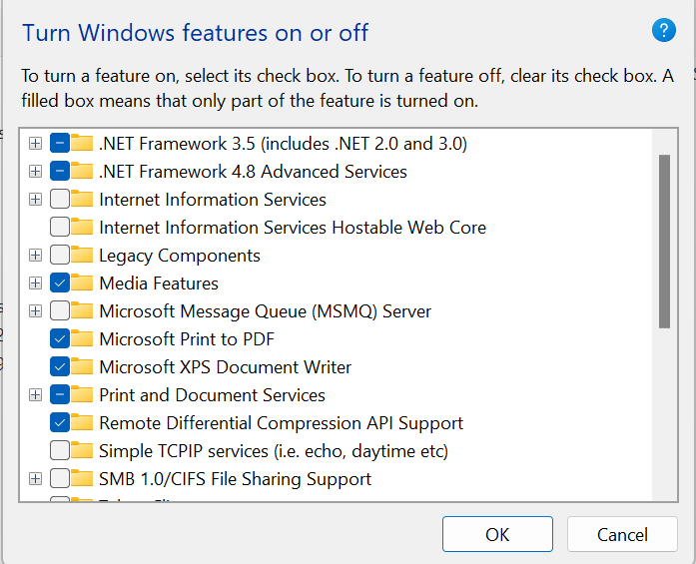

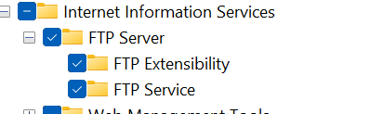

* Open Internet Information Services (IIS) Manager.

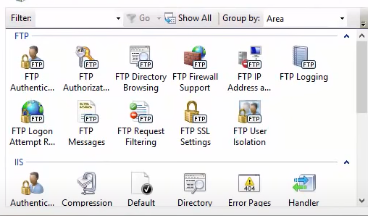

* Go to site -> Add FTP Site -> Give name and path -> Give IP Address, check start FTP site automatically, No SSL -> Give authentication, access and permission -> Finish.

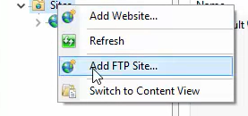

* Add site information

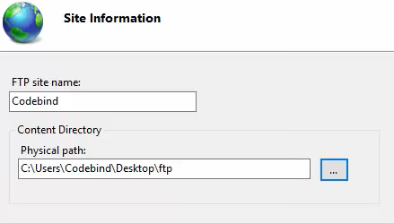

* Once, the site is created, go to windows firewall and allow it through windows firewall.

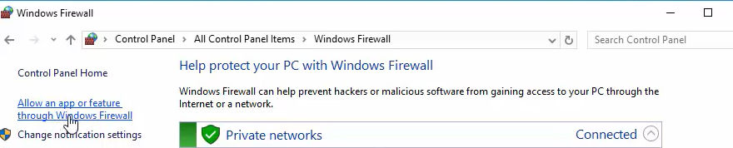

* Select the FTP server

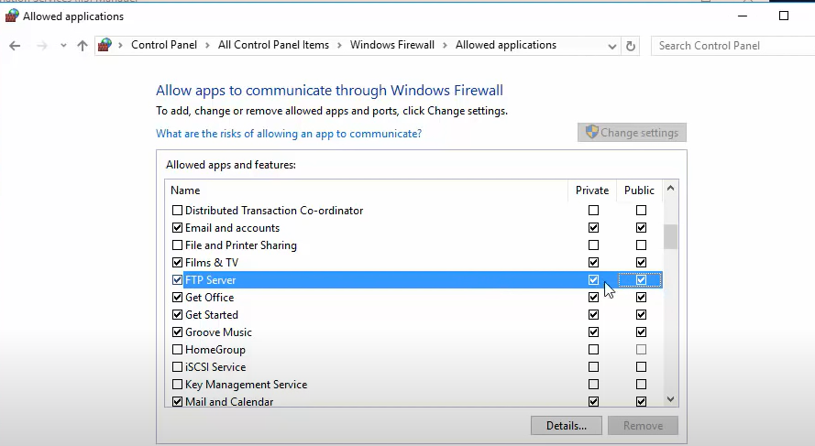

* Then, turn-off the firewall

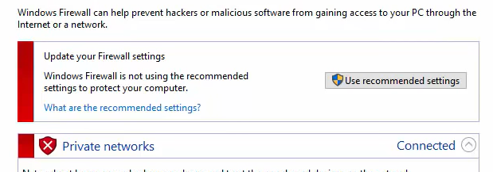

* Now, to access the FTP server, we can use one of the two methods.
* We can use either command prompt or ftp command in the browser.

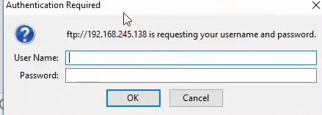

* You will need to enter the username and password.

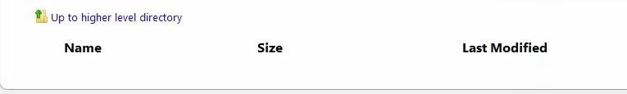

* Then, we can create some files and folders.

**CONCLUSION**

* In this practical, I learnt how to create a FTP server.